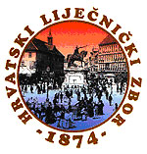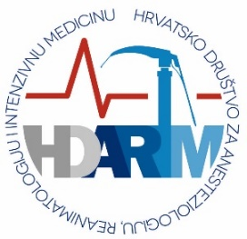

HRVATSKI LIJEČNIČKI ZBOR – CROATIAN MEDICAL ASSOCIATION
HRVATSKO DRUŠTVO ZA ANESTEZIOLOGIJU, REANIMATOLOGIJU I INTENZIVNU MEDICINU
CROATIAN ASSOCIATION OF ANESTHESIOLOGY, REANIMATOLOGY AND ICM

Individual society member of ESAIC (European Society of Anaesthesiology and Intensive Care)

PLEASE TICK THE BOX AND SIGN
☐ I hereby request as a member of the CROATIAN MEDICAL ASSOCIATION – CROATIAN ASSOCIATION OF ANESTHESIOLOGY, REANIMATOLOGY AND ICM to become an individual society member of the ESAIC and approve that the CROATIAN MEDICAL ASSOCIATION – CROATIAN ASSOCIATION OF ANESTHESIOLOGY, REANIMATOLOGY AND ICM shares the following data with the ESAIC:

First name:

Last name:

Email address:

Title:

Date of birth:

Country:

Date:Click or tap to enter a date.

